Introduction
This guide covers advanced SQL functions and techniques that are essential for data transformation and analysis. Using data from a farmers' market schema, we'll explore how to perform operations such as pivoting data, unpivoting, rolling calculations, retrieving nth values, and combining datasets with UNION and UNION ALL.
1. Pivoting Data Using CASE Statements
Purpose
Transform rows into columns using the CASE statement in SQL. This technique is useful for summarizing data across different categories or time periods.
Syntax Explanation
SELECT
GroupingColumn,
SUM(CASE WHEN ConditionColumn = Value1 THEN AggregateColumn ELSE 0 END) AS NewColumn1,
SUM(CASE WHEN ConditionColumn = Value2 THEN AggregateColumn ELSE 0 END) AS NewColumn2
FROM
TableName
GROUP BY
GroupingColumn;

Example Queries
Example Query 1: Basic Pivoting to sum quantities by market_date and customer_id.
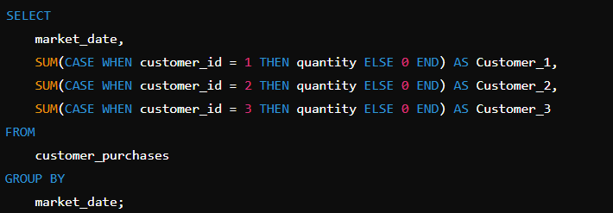

Example Query 2: Pivoting to find the maximum quantity by market_date and vendor_id.
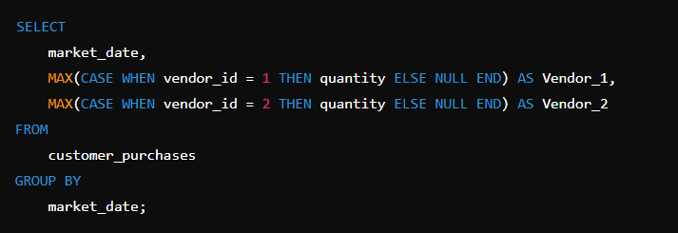
Example Query 3: Pivoting with multiple groupings (e.g., product_id and market_date).
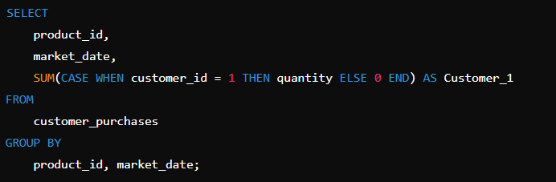
Example Query 4: Conditional Pivoting to include only purchases greater than a specific value.
SELECT
market_date,
SUM(CASE WHEN customer_id = 1 AND quantity > 1 THEN quantity ELSE 0 END) AS Customer_1
FROM
customer_purchases
GROUP BY
market_date;

2. Unpivoting Data Using UNION ALL
Purpose
Convert columns back into rows using the UNION ALL statement. This method is useful for normalizing data or preparing it for further analysis.

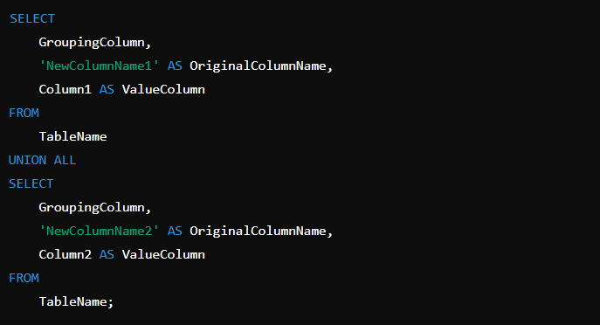

3. Rolling Calculations
Purpose
Perform aggregate operations over a window of rows, typically used to analyze trends over time.
SELECT
ColumnA,
ColumnB,
AggregateFunction(ColumnC) OVER (PARTITION BY ColumnA ORDER BY ColumnB ROWS BETWEEN N PRECEDING AND CURRENT ROW) AS RollingAggregate
FROM
TableName;

Example Queries
Example Query 1: Basic Rolling Sum of quantity over 3 market dates.
SELECT
market_date,
customer_id,
SUM(quantity) OVER (PARTITION BY customer_id ORDER BY market_date ROWS BETWEEN 2 PRECEDING AND CURRENT ROW) AS RollingSum
FROM
customer_purchases;

Example Query 2: Rolling Average of cost_to_customer_per_qty over the last 5 transactions.

SELECT
customer_id,
market_date,
AVG(cost_to_customer_per_qty) OVER (PARTITION BY customer_id ORDER BY market_date ROWS BETWEEN 4 PRECEDING AND CURRENT ROW) AS RollingAvg
FROM
customer_purchases;

4. NTH_VALUE Function
Purpose
Retrieve the nth value from a set of ordered data, which is useful for ranking and analyzing specific entries within a group.
SELECT
ColumnA,
NTH_VALUE(ColumnB, N) OVER (PARTITION BY ColumnA ORDER BY ColumnC ROWS BETWEEN UNBOUNDED PRECEDING AND UNBOUNDED FOLLOWING) AS NthValue
FROM
TableName;

Example Queries
Example Query 1: Retrieve the 2nd highest quantity for each customer_id.
SELECT
customer_id,
NTH_VALUE(quantity, 2) OVER (PARTITION BY customer_id ORDER BY quantity DESC ROWS BETWEEN UNBOUNDED PRECEDING AND UNBOUNDED FOLLOWING) AS SecondHighestQuantity
FROM
customer_purchases;

Example Query 2: Find the 3rd earliest transaction_time for each vendor_id.

SELECT
vendor_id,
NTH_VALUE(transaction_time, 3) OVER (PARTITION BY vendor_id ORDER BY transaction_time ASC ROWS BETWEEN UNBOUNDED PRECEDING AND UNBOUNDED FOLLOWING) AS ThirdEarliestTransaction
FROM
customer_purchases;

5. UNION and UNION ALL
Purpose
Combine results from multiple SELECT queries into a single result set.
SELECT
Column1,
Column2
FROM
TableA
UNION [ALL]
SELECT
Column1,
Column2
FROM
TableB;

Example Queries
Example Query 1: Basic UNION to combine purchases from two different market dates.
SELECT
customer_id,
quantity
FROM
customer_purchases
WHERE
market_date = '2023-07-01'
UNION
SELECT
customer_id,
quantity
FROM
customer_purchases
WHERE
market_date = '2023-07-08';

